S.Y.T.R. GOVT. DEGREE COLLEGE
MADAKASIRA JAWAHAR KNOWLEDGE CENTER (JKC)



JKC ANNUAL REPORT
2023-24



JKC STAFF MEMBERS

S.No. | Name | Designation | Qualification | Cell No.
1 | Dr.R.Subbaiah | Principal & JKC Chairman | M.A., Ph.D | 9704406695
2 | R.Hemalatha | JKC Coordinator | M.Sc., | 9492623696
3 | K.N.Venkatesh | JKC Full Time Mentor | M.B.A  (H.R & FINANCE) | 8179411035

Conducted Campus Drive on 24-04-2023
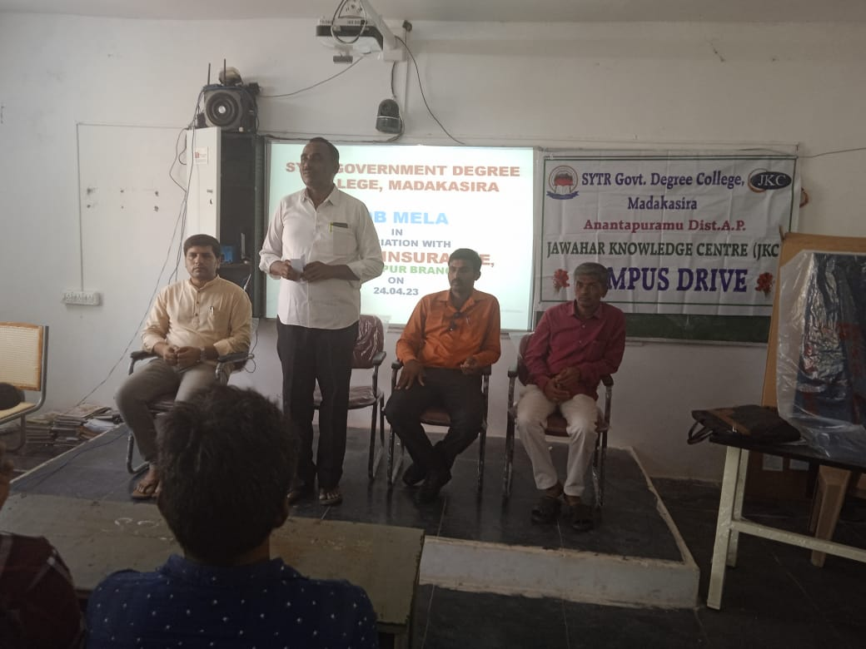
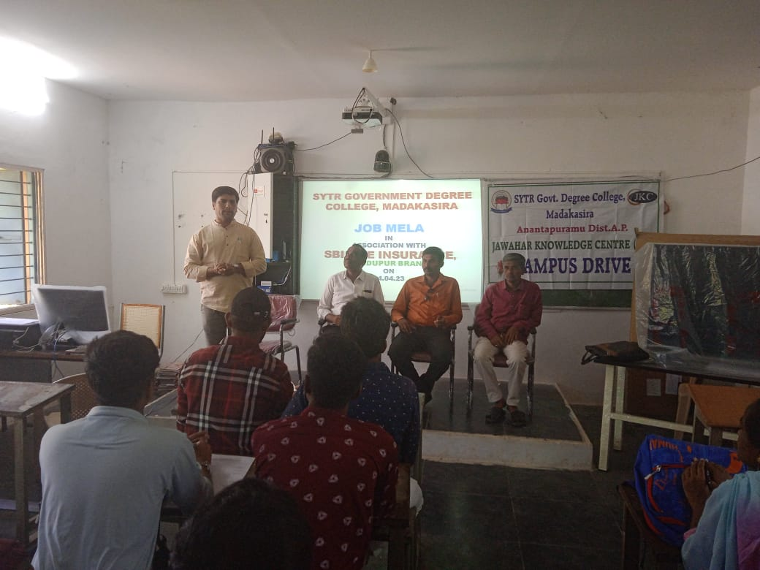
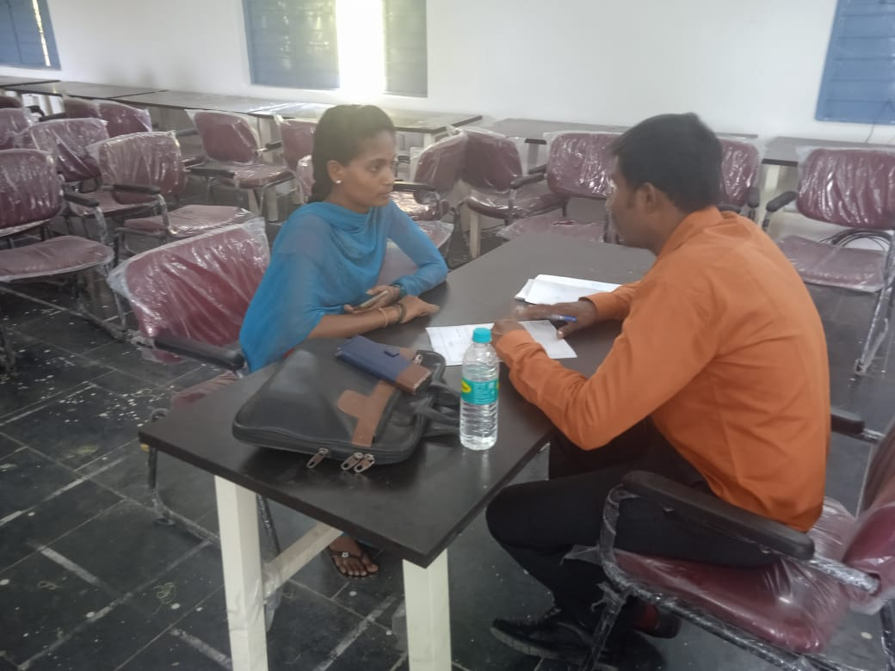
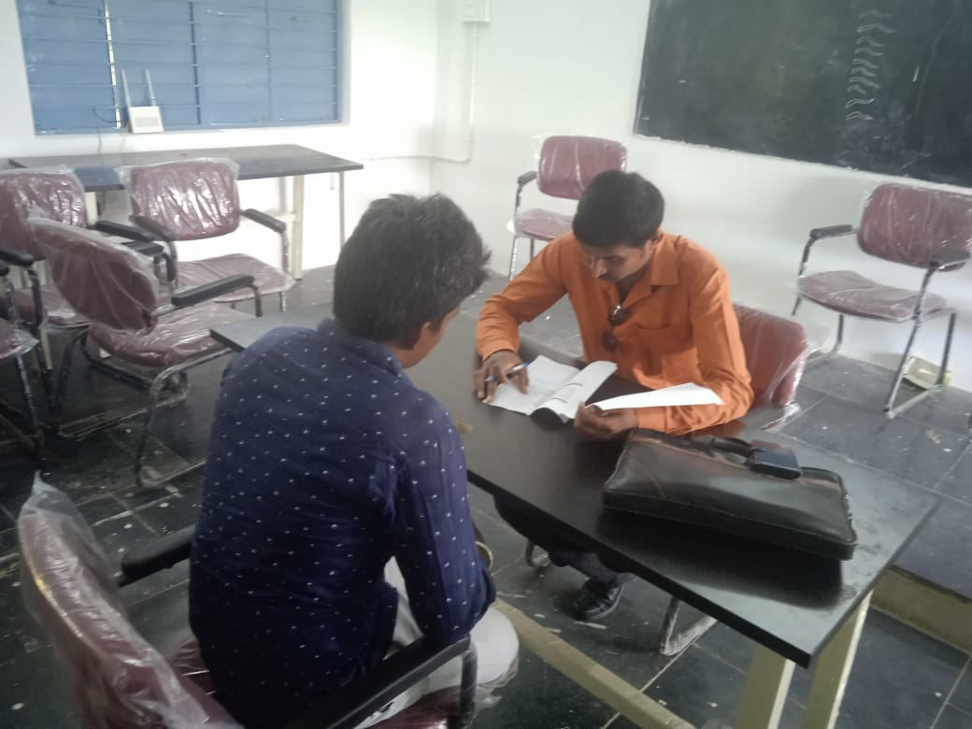
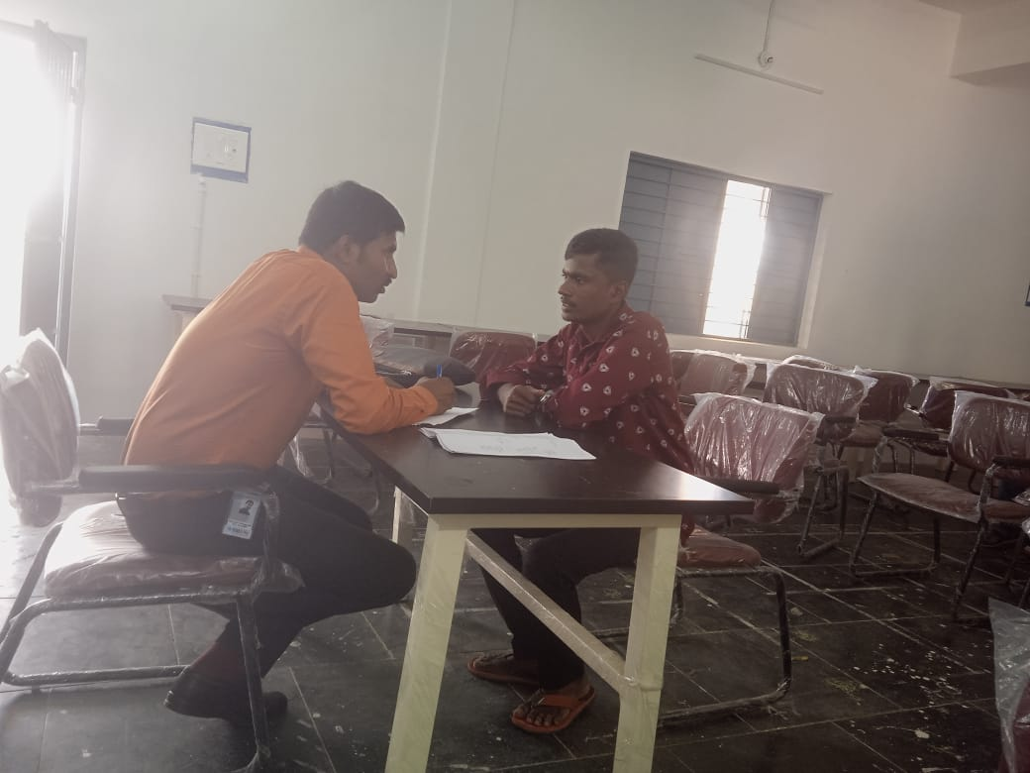
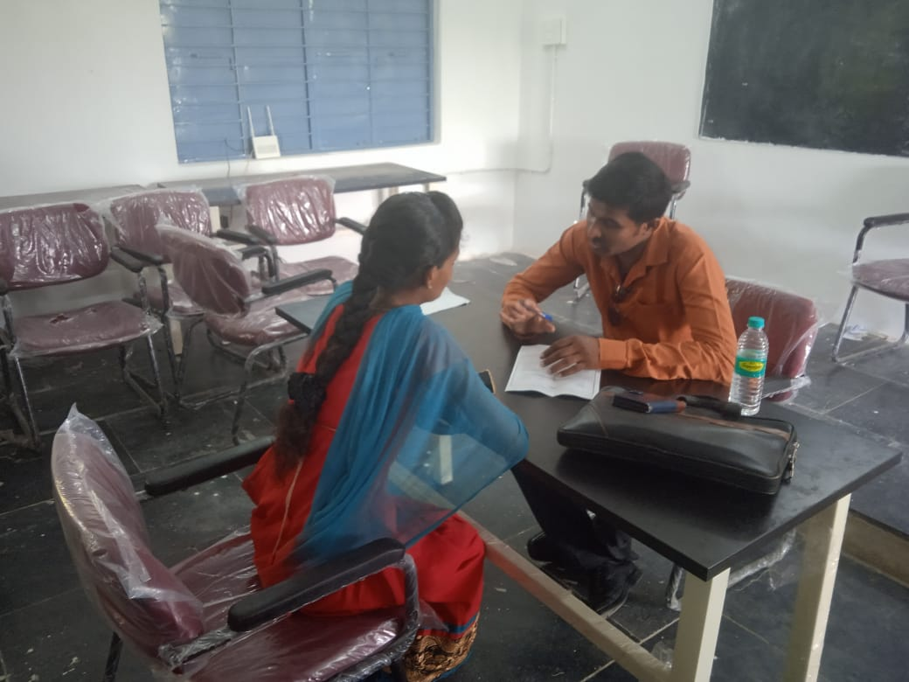
Sri.A.Manjunath, Development Officer, SBI, Hindupur Branch conducted interviews

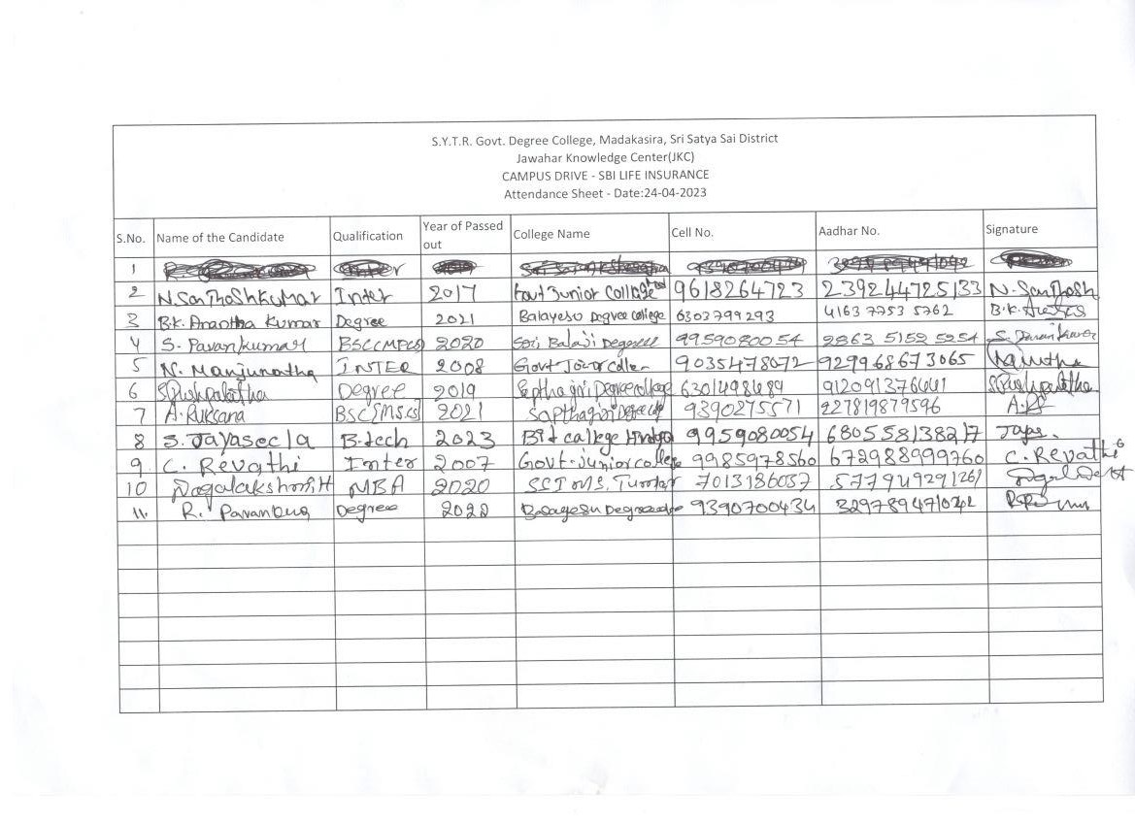

JKC Registered Students Data 3 BATCHES - 2023 - 24
S.NO. | Student Id | Student Name | Date of Birth | Gender | Social Status | Degree Group/Combination | JKC Batch
1 | JKC202301591 | D G DEVARAJU | 2/4/2003 | Male | BC | BA EPP | I
2 | JKC202301594 | N MARUTHI | 14-05-2003 | Male | BC | BA EHP | I
3 | JKC202301600 | B N MURTHY | 24-04-2004 | Male | SC | BA EHP | I
4 | JKC202301607 | N SUNITHA | 20-02-2001 | Female | SC | BA EHP | I
5 | JKC202301615 | P RADHIKA | 7/7/2004 | Female | SC | BA EHP | I
6 | JKC202301626 | E JAGADEESH | 30-06-2004 | Male | SC | BA EHP | I
7 | JKC202301634 | M RAGHU | 12/7/2004 | Male | SC | BA EHP | I
8 | JKC202301639 | G GOWTHAMI | 12/6/2004 | Female | SC | BA EHP | I
9 | JKC202301648 | T PRAMEELA | 7/3/2004 | Female | SC | BA EHP | I
10 | JKC202301654 | E SARASWATHI | 1/6/2003 | Female | SC | BA EHP | I
11 | JKC202301663 | G ANJINEYULU | 15-05-2004 | Male | SC | BA EHP | I
12 | JKC202301672 | J MAHALAKSHMI | 15-05-2002 | Female | BC | BA EPP | I
13 | JKC202301679 | C PRASANNA KUMAR | 14-06-2004 | Male | BC | B.Com | I
14 | JKC202301691 | R ANIL KUMAR | 25-06-2003 | Male | OC | B.Com | I
15 | JKC202301698 | P RAMESH | 18-06-2004 | Male | SC | B.Com | I
16 | JKC202301703 | G ANJI | 9/11/2003 | Male | SC | B.Com | I
17 | JKC202301710 | G CHINNIKRISHNA | 2/2/2004 | Male | BC | B.Com | I
18 | JKC202301717 | C SREEDHAR | 27-06-2004 | Male | BC | B.Com | I
19 | JKC202301725 | N KARIYANNA | 23-03-2004 | Male | BC | B.Com | I
20 | JKC202301733 | H THIMMA REDDY | 4/11/2003 | Male | BC | B.Com | I
21 | JKC202301846 | H SIDDARAJU | 3/3/2023 | Male | BC | B.Com | I
22 | JKC202301851 | S TEJASWINI | 25-05-2003 | Female | SC | B.Com | I
23 | JKC202301857 | C INDRANI | 6/10/2001 | Female | SC | B.Com | I
24 | JKC202301862 | N NIRMALA PRIYA | 26-09-2004 | Female | SC | B.Com | I
25 | JKC202301867 | D BRAMHENDRA | 12/11/2003 | Male | BC | B.Com | I
26 | JKC202301873 | N SREERAM REDDY | 1/2/2003 | Male | BC | B.Com | I
27 | JKC202301878 | H KANTHARAJU | 13-06-2004 | Male | BC | B.Com | I
28 | JKC202301886 | A LAKSHMIKANTH | 1/1/2004 | Male | BC | B.Com | I
29 | JKC202301894 | A VENU | 30-07-2003 | Male | SC | B.Com | I
30 | JKC202301898 | H SATHISH KUMAR | 9/5/2002 | Male | BC | B.Com | I
31 | JKC202303819 | B BHAGYALAKSHMI | 19-08-1999 | Female | SC | MPC | II
32 | JKC202303820 | B PAVAN KUMAR | 25-03-2005 | Male | BC | MPC | II
33 | JKC202303822 | G N SURESH | 3/1/1996 | Male | BC | MPC | II
34 | JKC202303823 | S JYOTHI | 17-03-2004 | Female | BC | MPC | II
35 | JKC202303825 | S ANITHA | 28-01-2004 | Female | SC | MPC | II
36 | JKC202303868 | H MAHESH | 15-04-2000 | Male | SC | BZC | II
37 | JKC202303870 | P PUSHPALATHA | 15-06-2005 | Female | BC | BZC | II
38 | JKC202303872 | HANUMANTHARAYAPPA GARI PUSHPA | 12/12/2004 | Female | BC | BZC | II
39 | JKC202303876 | K GEETHAMMA | 20-06-2005 | Female | BC | BZC | II
40 | JKC202303880 | N LIKHITA | 5/2/2005 | Female | BC | BZC | II
41 | JKC202303883 | O SOUNDARYA | 16-12-2004 | Female | SC | BZC | II
42 | JKC202303885 | R ADDESH | 20-06-2005 | Male | SC | BZC | II
43 | JKC202303888 | S SHALINI | 29-10-2004 | Female | SC | BZC | II
44 | JKC202303890 | S DHARANI | 4/10/2003 | Female | SC | BZC | II
45 | JKC202303896 | S SAVITHRI | 31-05-2005 | Female | SC | BZC | II
46 | JKC202303898 | T PAVITHRA | 11/5/2005 | Female | SC | BZC | II
47 | JKC202305495 | A LAKSHMIPATHI | 1/1/2004 | Male | BC | B.COM GERNERAL | III
48 | JKC202305497 | T RANJITHA | 15-03-2004 | Male | SC | BA EHP | III
49 | JKC202305499 | T PRAMEELA | 7/3/2004 | Female | SC | BA EHP | III
50 | JKC202305506 | C INDRANI | 6/10/2001 | Female | SC | B.COM GERNERAL | III
51 | JKC202305511 | P KAVYA | 7/10/2023 | Female | BC | B.COM CA | III
52 | JKC202305516 | N NANDINI | 6/6/2004 | Female | BC | B.COM GERNERAL | III
53 | JKC202305521 | N PREMA | 8/9/2003 | Female | SC | BA EHP | III
54 | JKC202305526 | H MYTHREE | 10/4/2004 | Female | BC | B.COM GERNERAL | III
55 | JKC202305529 | L SUGUNA | 3/5/2004 | Female | BC | B.COM GERNERAL | III
56 | JKC202305536 | S JAGADEESH | 6/3/2003 | Male | BC | BA EHP | III
57 | JKC202305554 | V ANJAN KUMAR | 26-07-2004 | Male | BC | BA EHP | III
58 | JKC202305561 | R SANJEEVA | 21-08-2004 | Male | SC | BA EHP | III
59 | JKC202305566 | A SRAVANI | 18-03-2004 | Female | BC | B.COM GERNERAL | III
60 | JKC202305618 | R UDAYA BANU | 20-11-2002 | Female | SC | BA EPP | III
61 | JKC202305621 | A NAGENDRA | 7/7/2002 | Male | SC | BA EHP | III
62 | JKC202305626 | R RAGHAVENDRA | 4/5/2003 | Male | BC | BA EPP | III
63 | JKC202305629 | B ANJI | 7/8/2003 | Male | BC | BA EHP | III
64 | JKC202305634 | R NITHIN | 24-02-2002 | Male | BC | BA EHP | III
65 | JKC202305639 | R MANJUNATH | 3/1/2004 | Male | SC | BA EPP | III
66 | JKC202305647 | P M PUSHPALATHA | 3/9/2002 | Female | BC | BA EHP | III
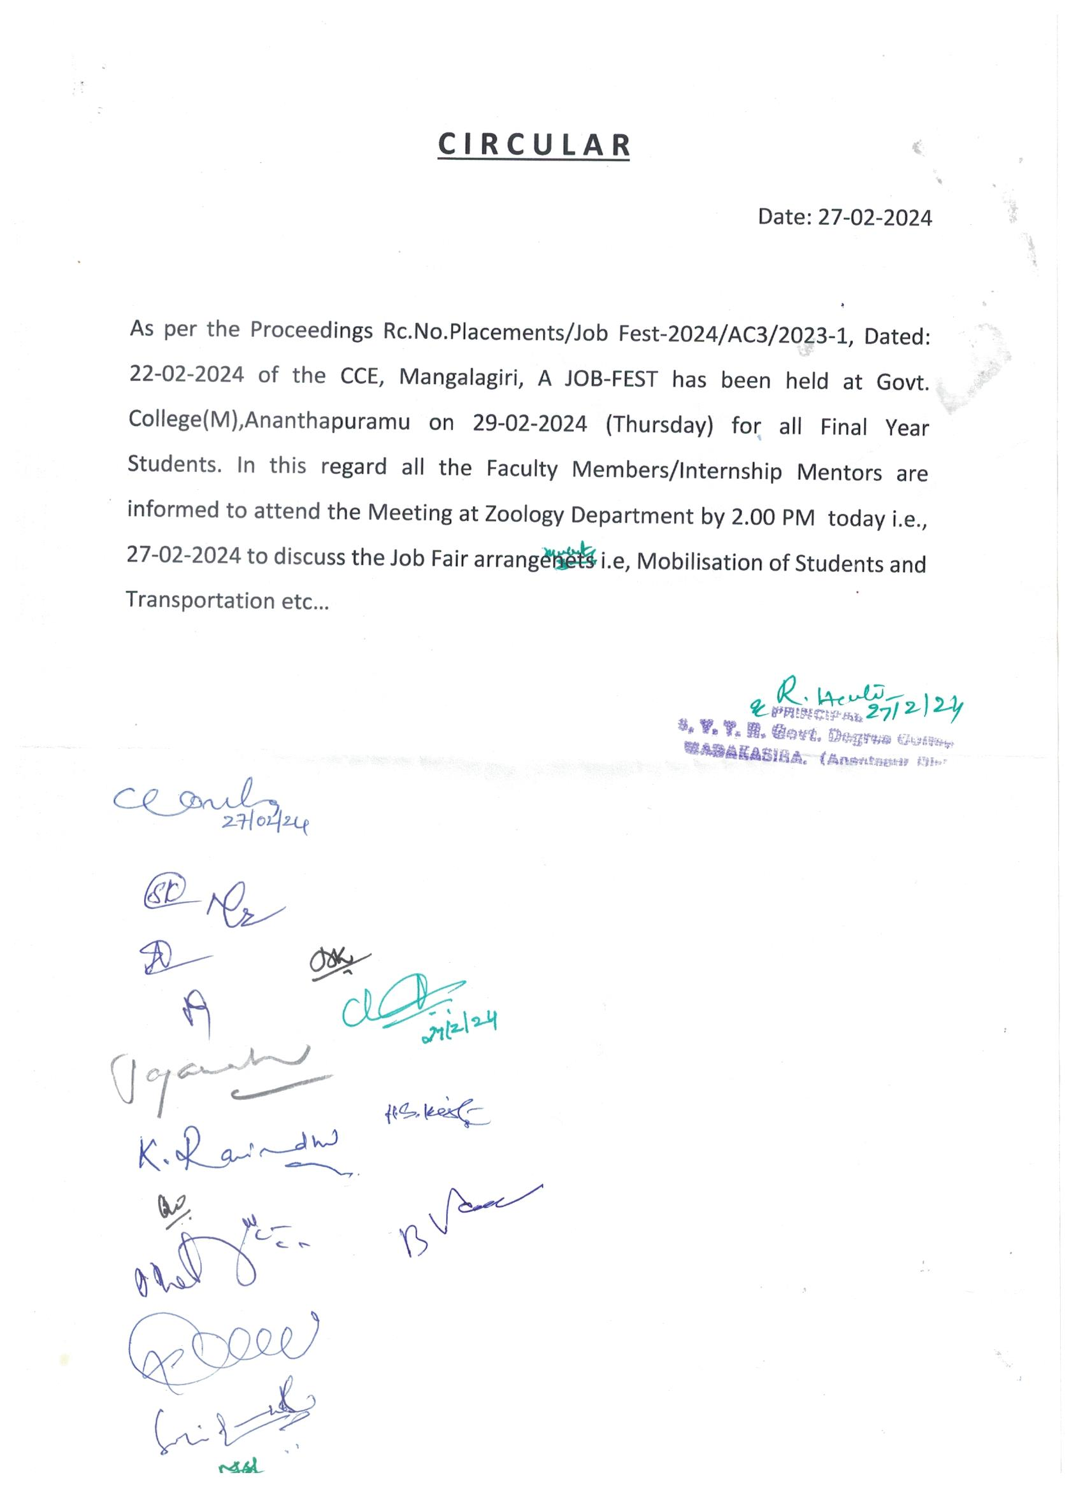

Mentor wise Students gathering for JOB FEST 2024 on 29-02-2024 at Govt. College (A), (M). Ananthapuramu
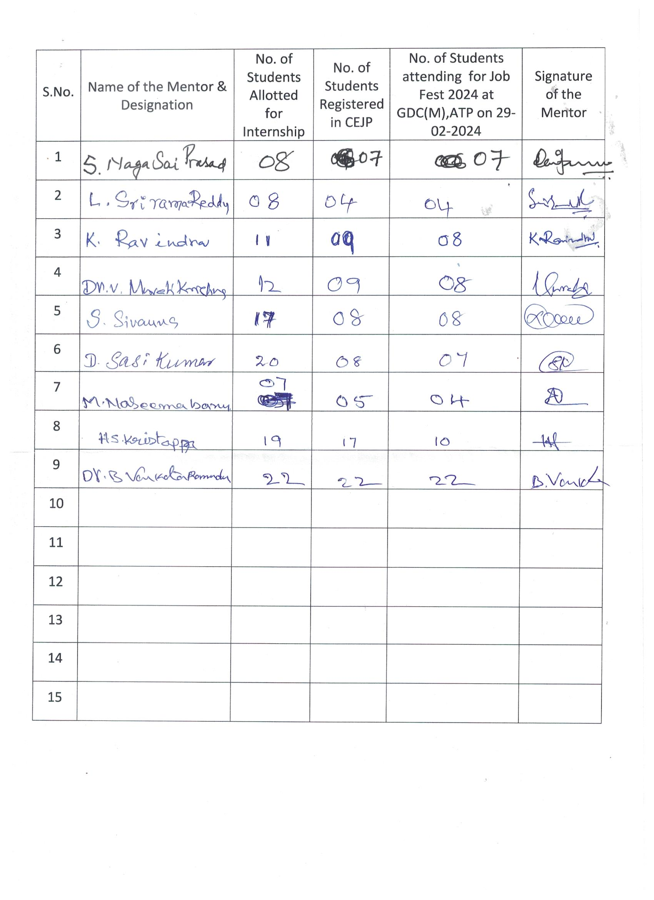
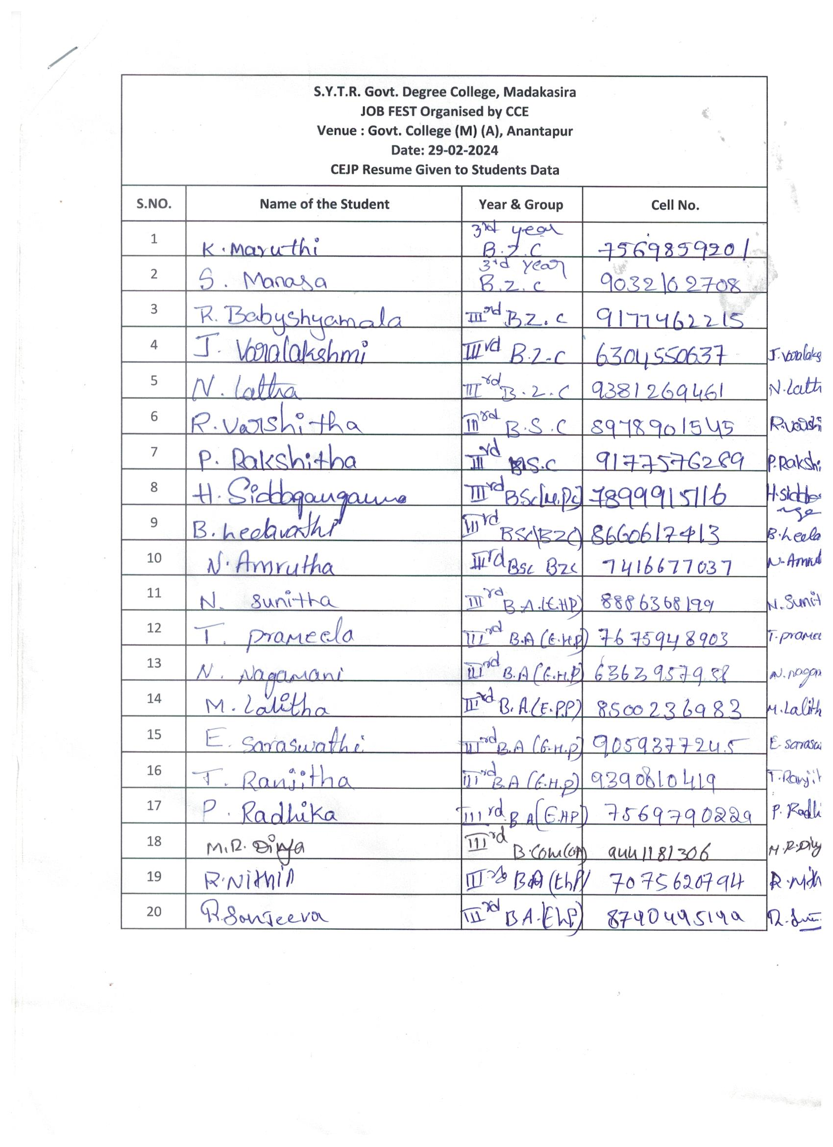
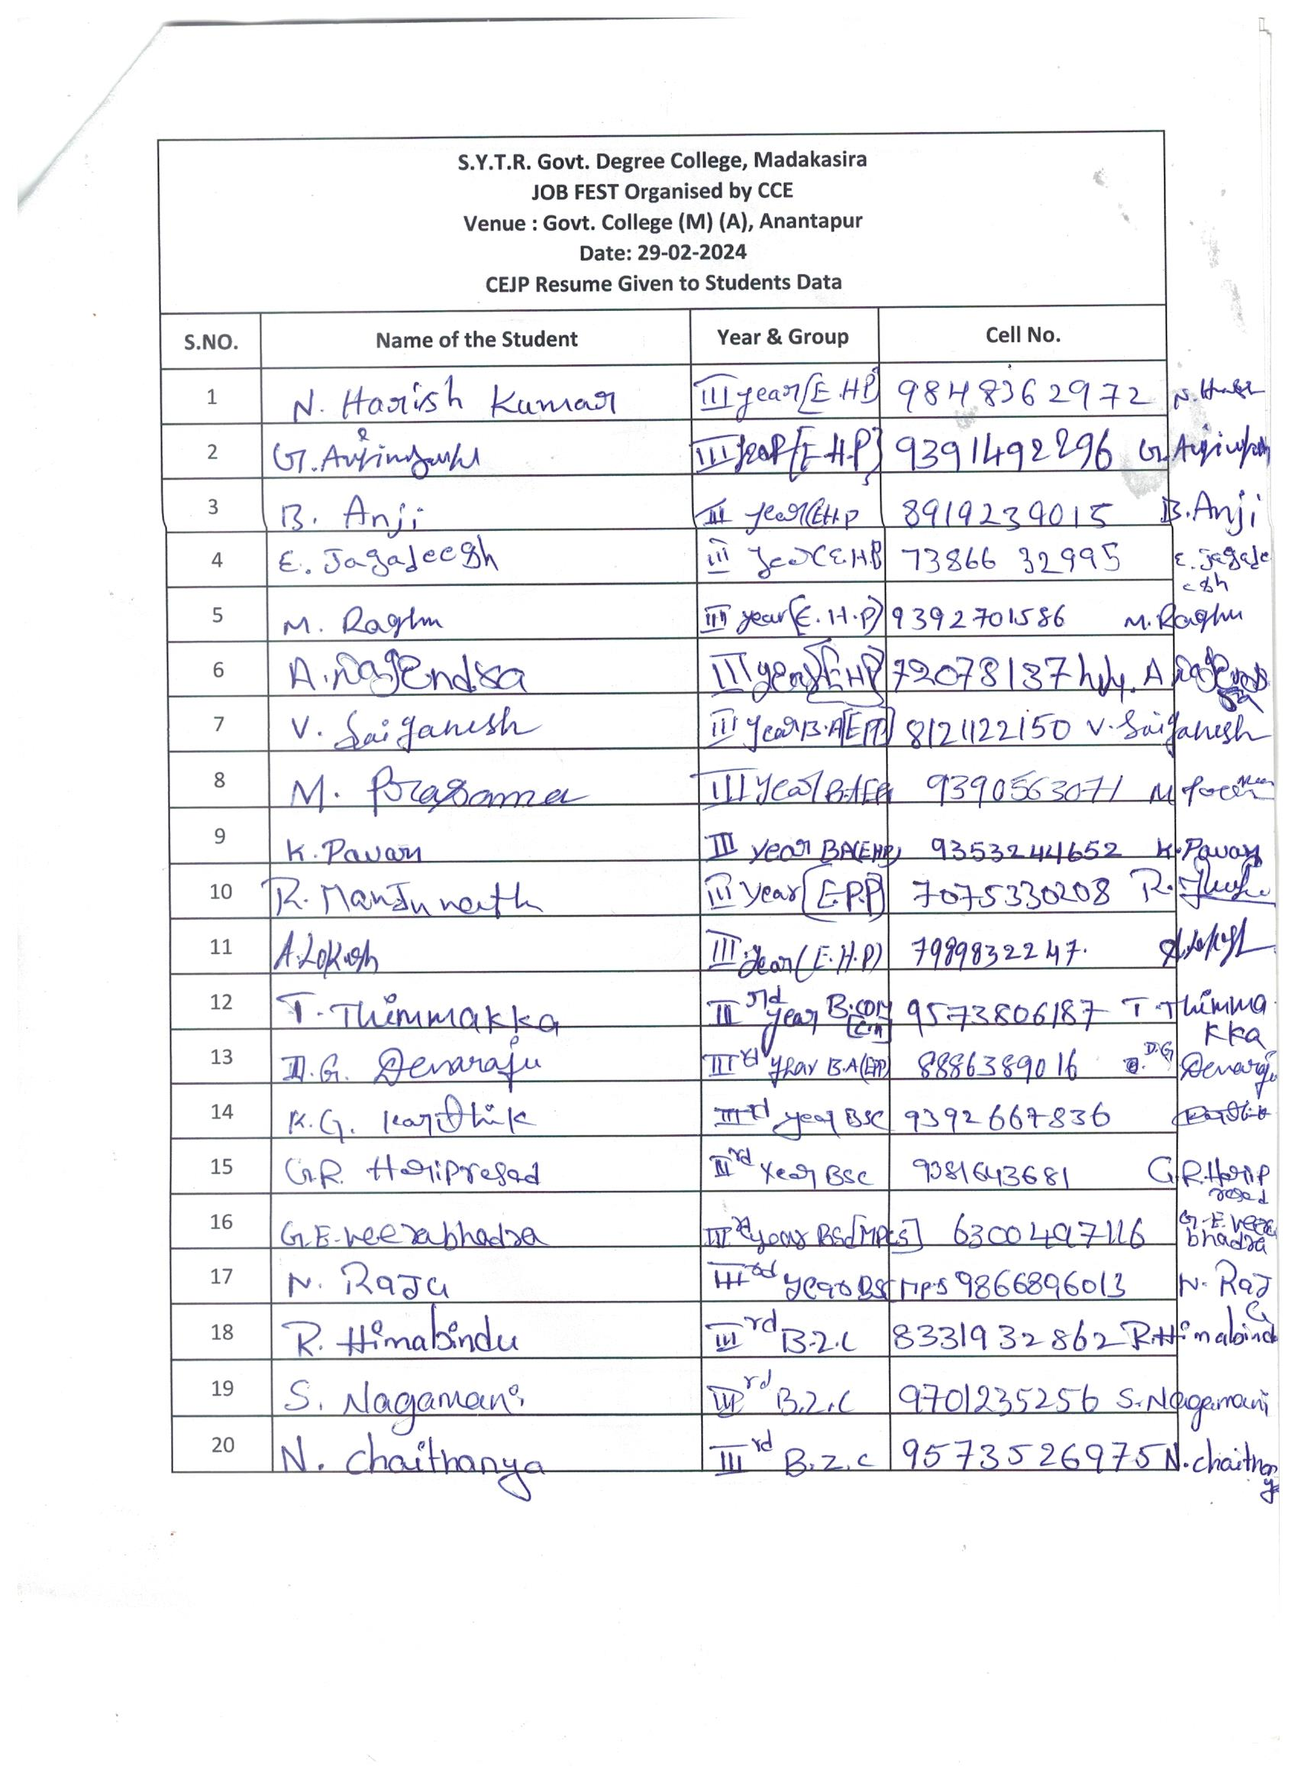
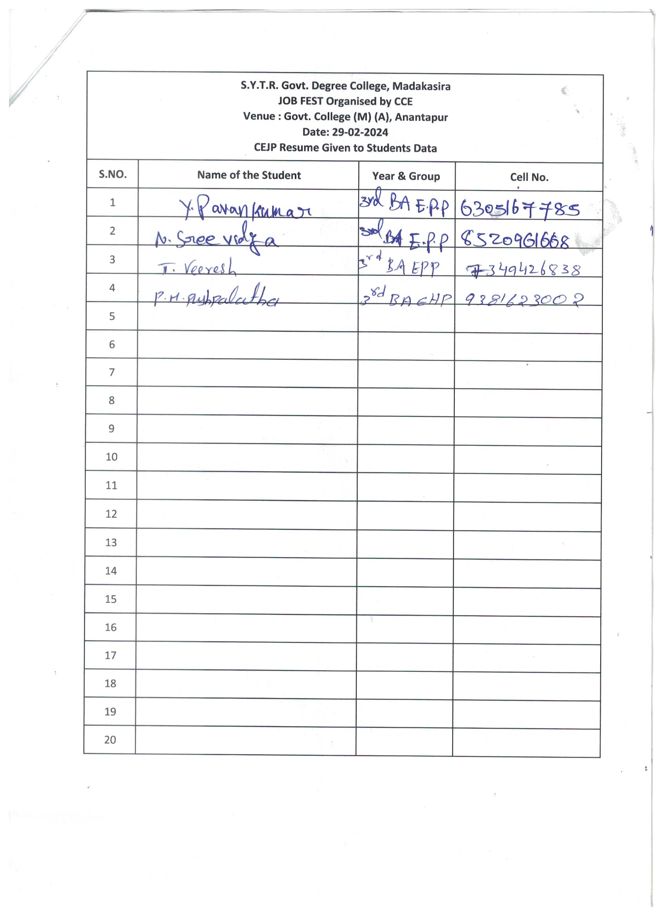

The College authorities are arranged a Bus for Staff and Students for attending JOB FEST on 29-02-2024 at Govt. College (A), (M). Ananthapuramu
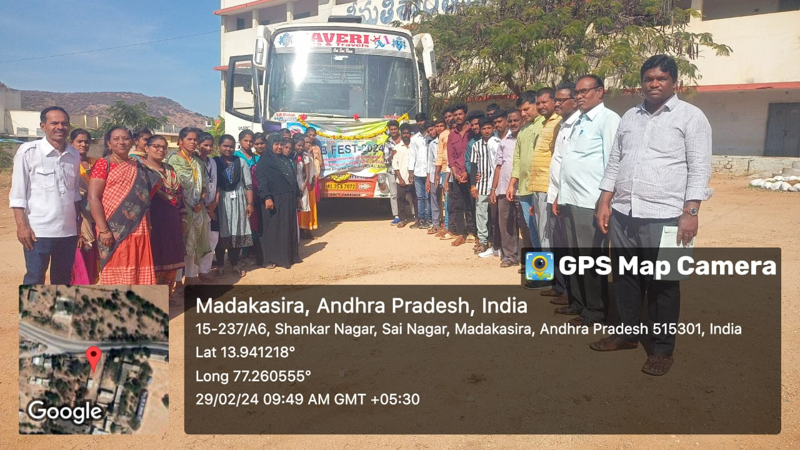
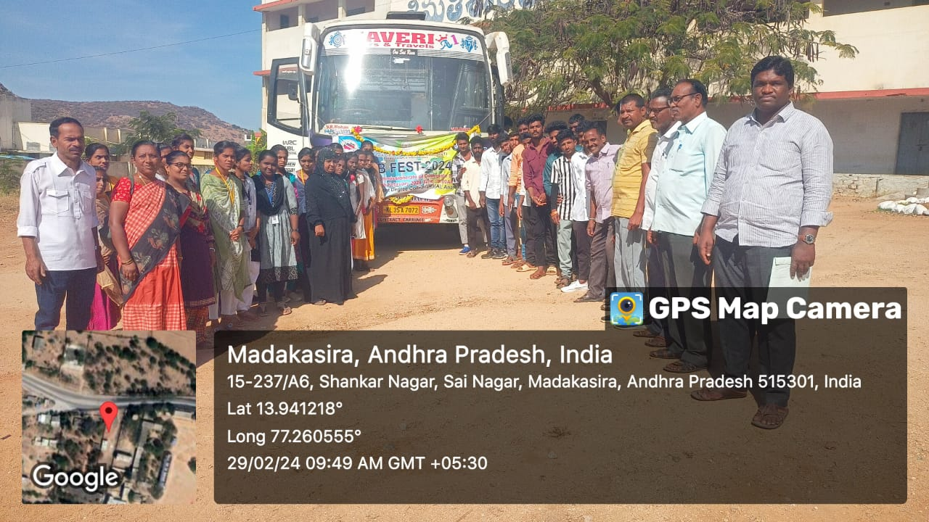
Students and Staff arrived at at Govt. College (A), (M). Ananthapuramu for attending JOB FEST
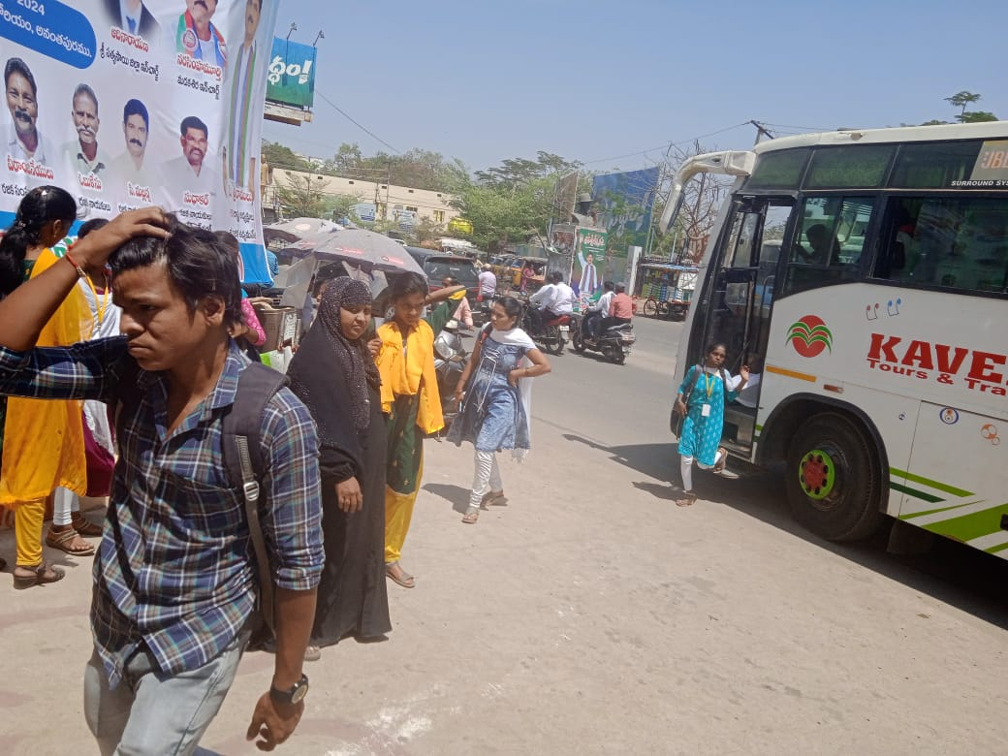
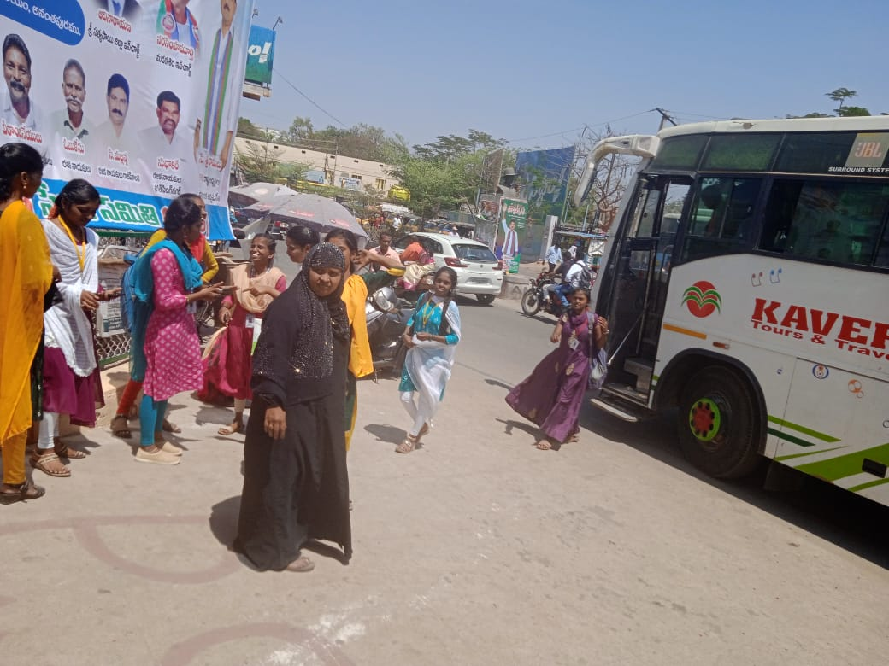

Dr.R.Subbaiah, Principal of the College and Staff members guide the students at Govt. College (A), (M). Ananthapuramu for attending JOB FEST
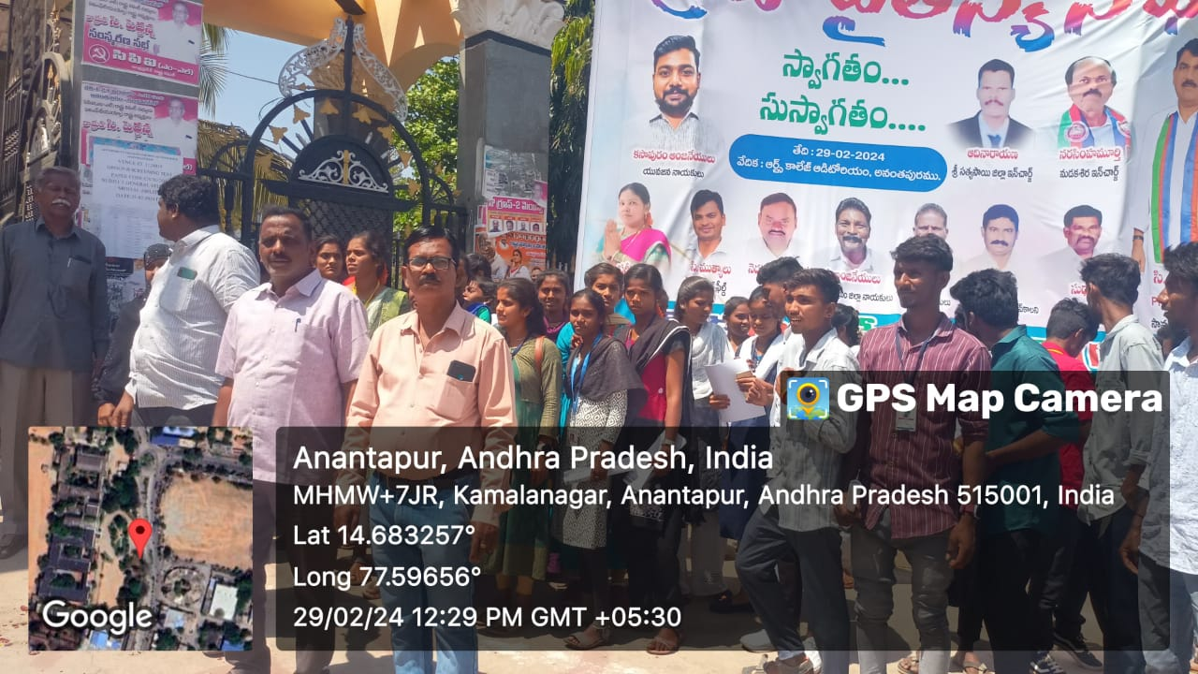
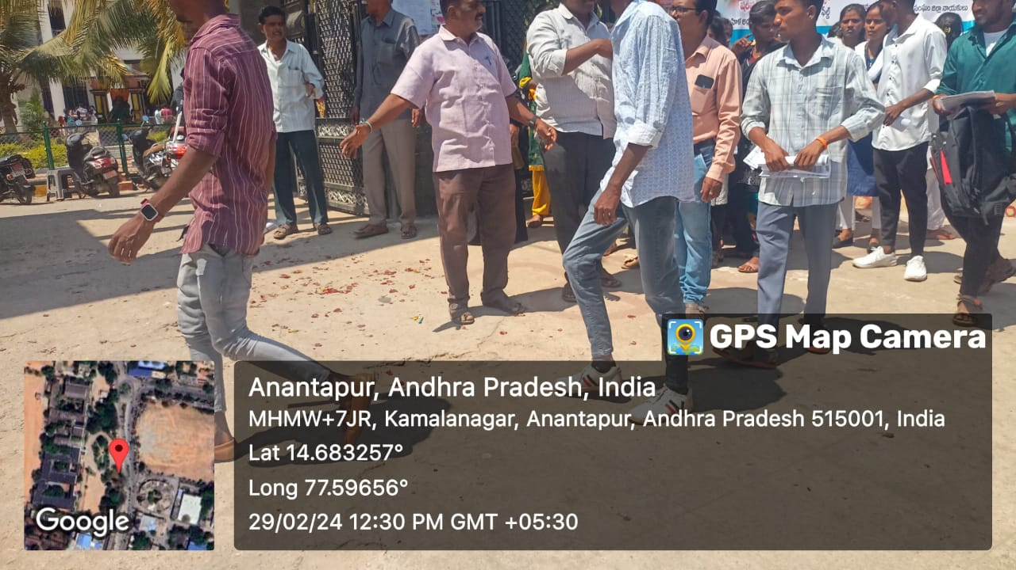

The students of S.Y.T.R. Govt. Degree College, Madakasira are viewing the companies list and room numbers for attending the interviews.
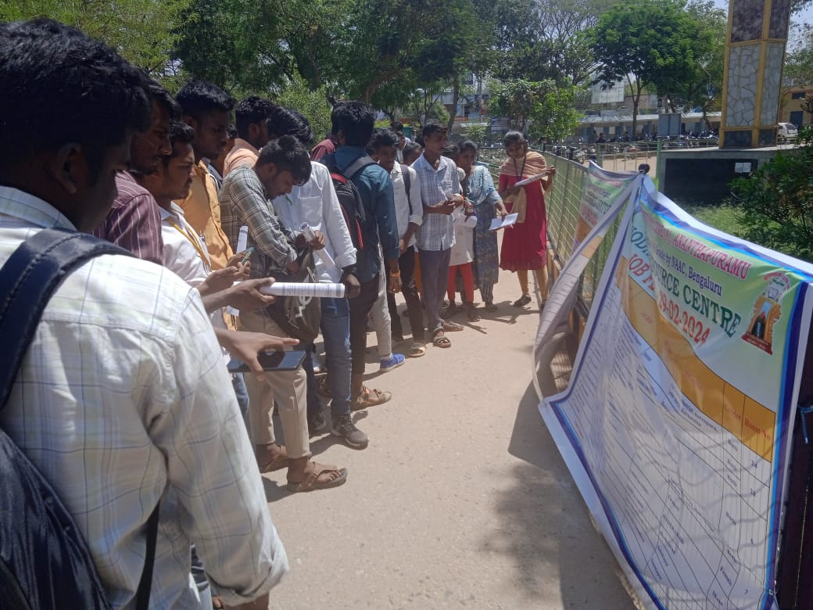

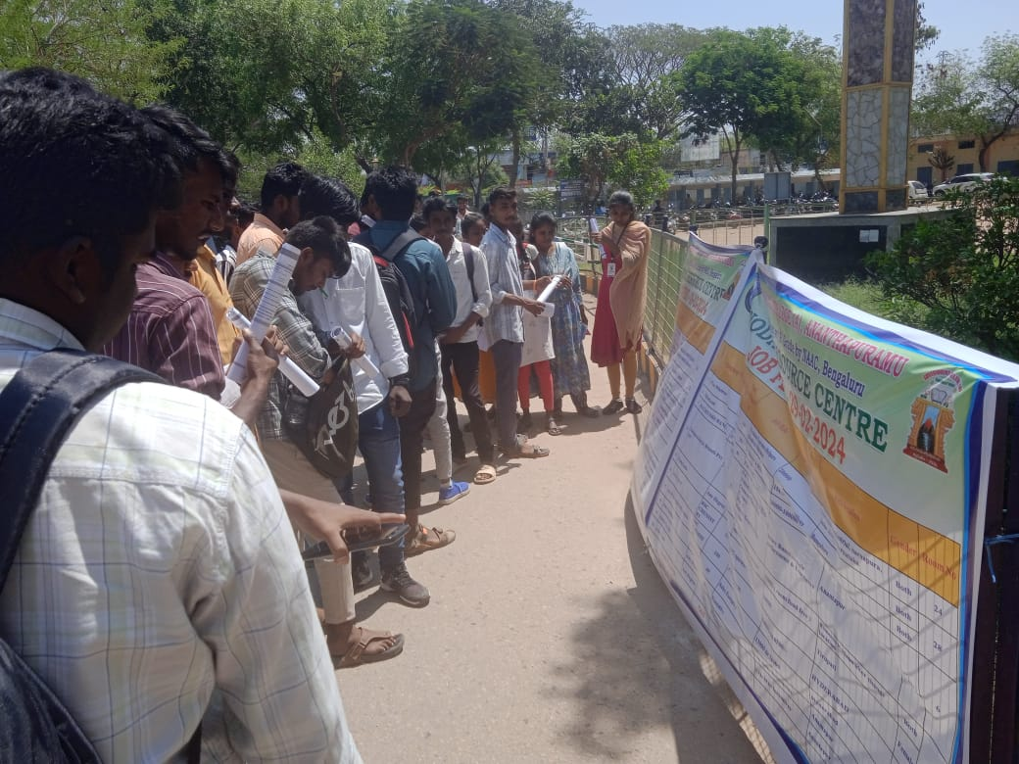
JOB-FEST Students Attendance sheet
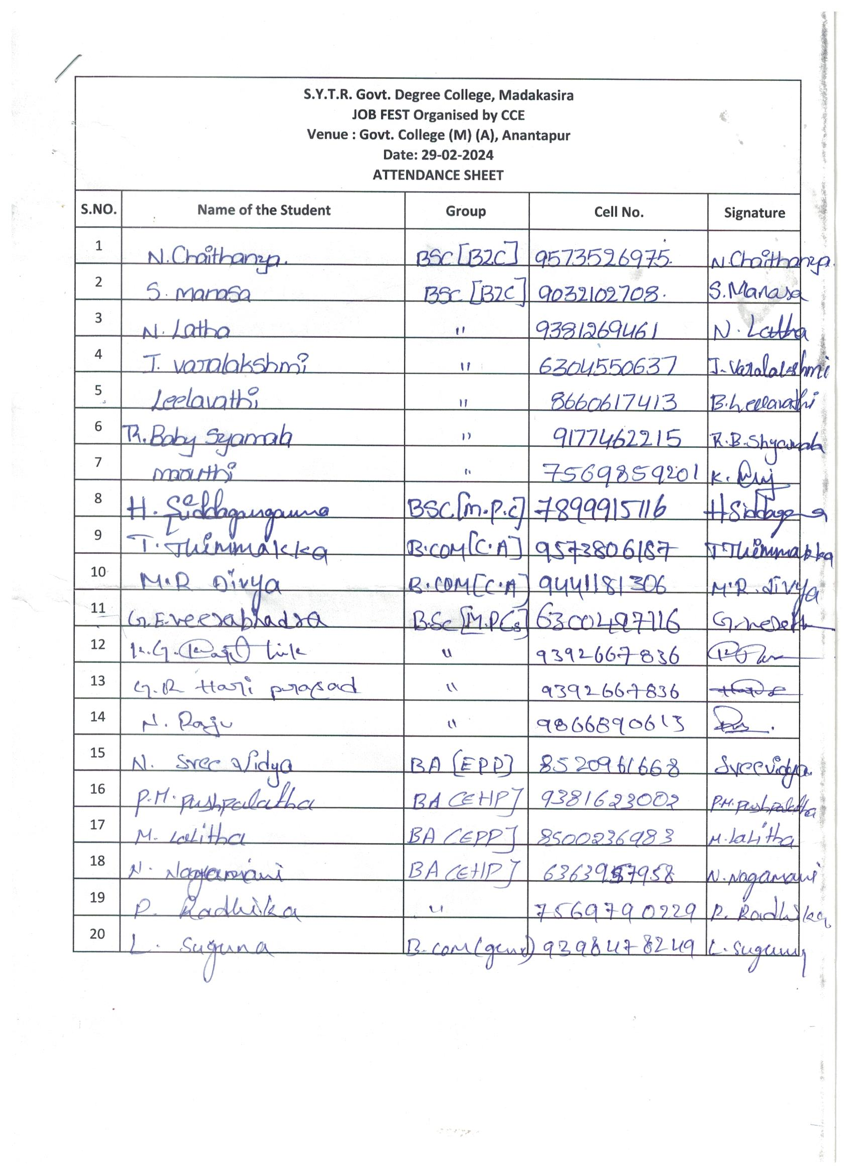
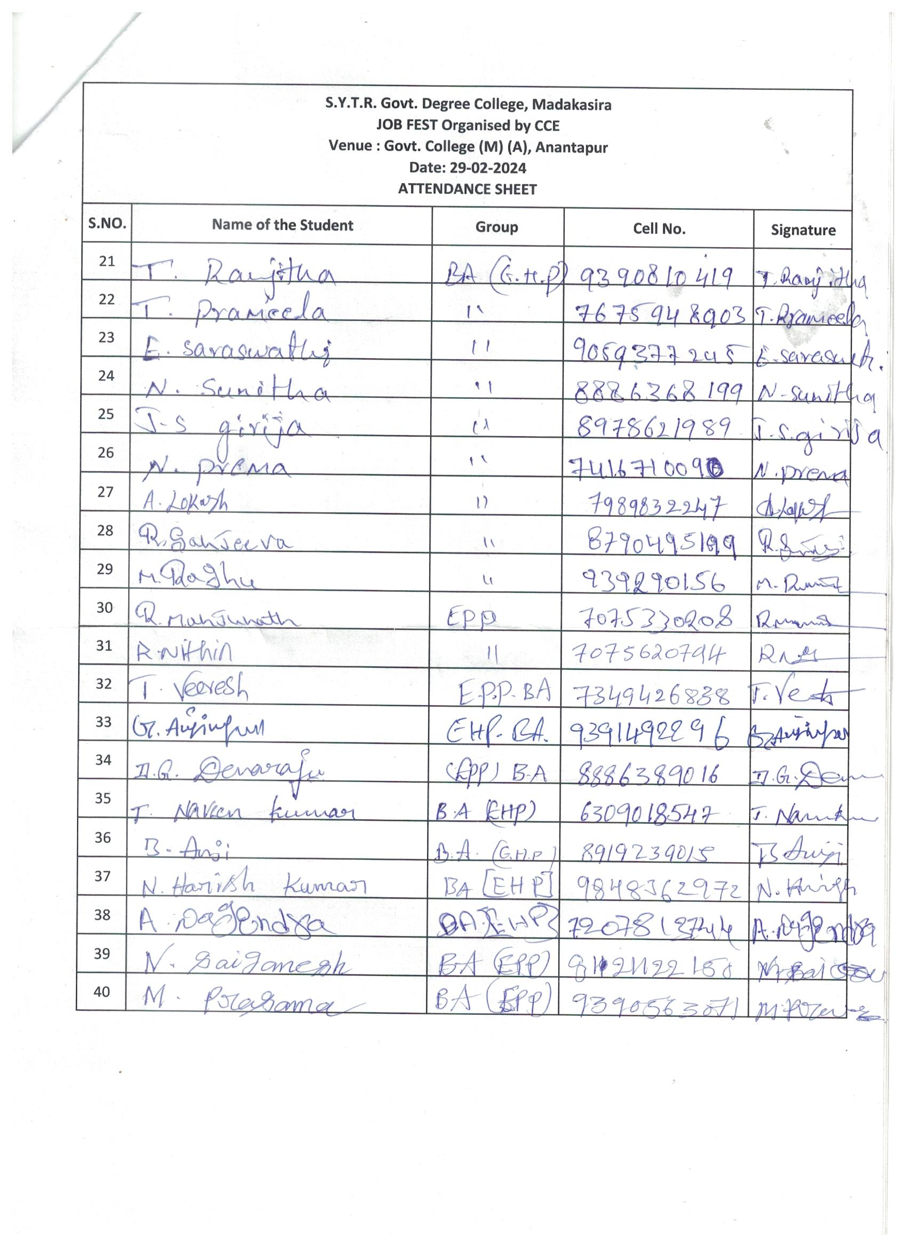
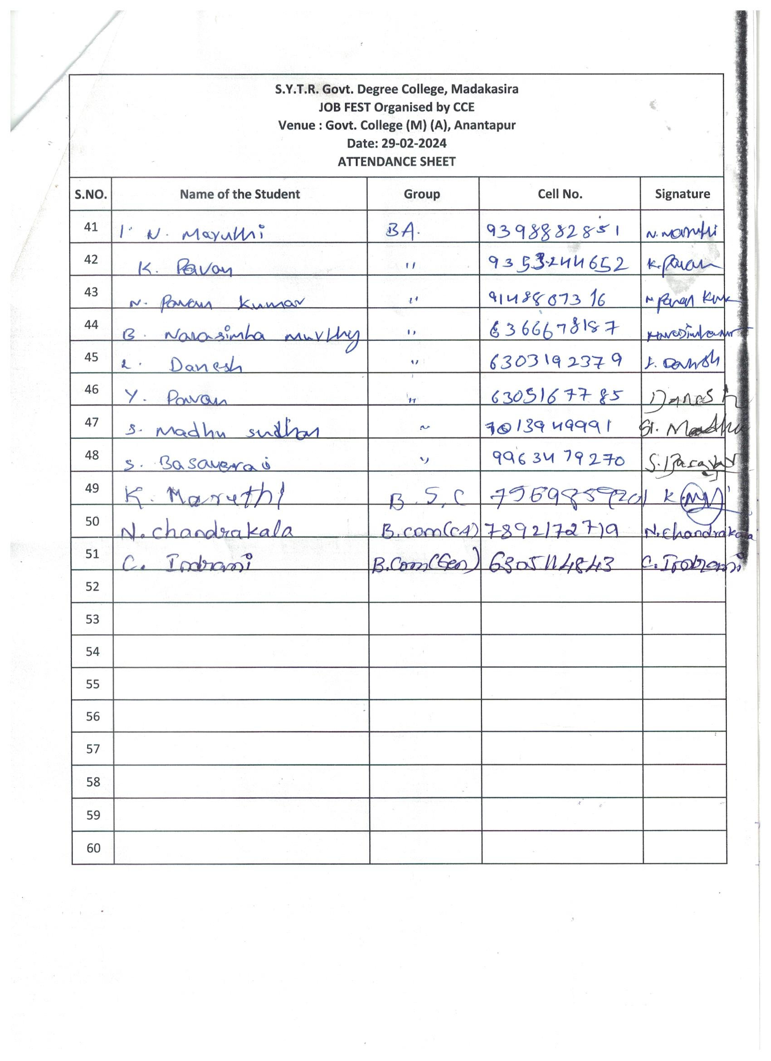
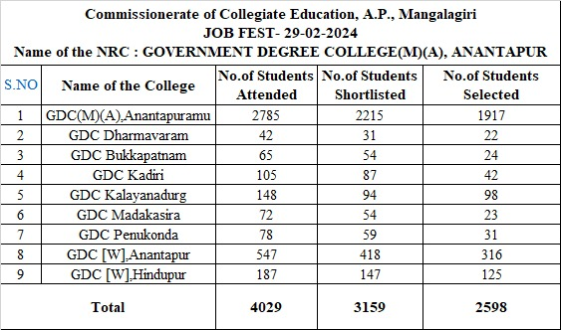

List of Students Selected in JOB FEST
S.No. | Zone | District | Name of the College | Name of the Student | Gender | Social Status | Group B.A.,B.Com., B.Sc
1 | IV | Sri Satya Sai | S.Y.T.R. Govt. Degree College, Madakasira | H.Siddagangamma | Femele | BC-A | B.Sc (MPC)
2 | IV | Sri Satya Sai | S.Y.T.R. Govt. Degree College, Madakasira | K.G.Karthik | Male | SC | B.Sc (MPCs)
3 | IV | Sri Satya Sai | S.Y.T.R. Govt. Degree College, Madakasira | G.R.Hariprasad | Male | SC | B.Sc (MPCs)
4 | IV | Sri Satya Sai | S.Y.T.R. Govt. Degree College, Madakasira | N.Raju | Male | BC-A | B.Sc (MPCs)
5 | IV | Sri Satya Sai | S.Y.T.R. Govt. Degree College, Madakasira | L.Suguna | Female | Bc-D | B.Com
6 | IV | Sri Satya Sai | S.Y.T.R. Govt. Degree College, Madakasira | M.Raghu | Male | SC | BA (EPP)
7 | IV | Sri Satya Sai | S.Y.T.R. Govt. Degree College, Madakasira | R.Sanjeeva | Male | SC | BA (EPP)
8 | IV | Sri Satya Sai | S.Y.T.R. Govt. Degree College, Madakasira | R.Manjunath | Male | SC | BA (EPP)
9 | IV | Sri Satya Sai | S.Y.T.R. Govt. Degree College, Madakasira | R.Nithin | Male | BC-A | BA (EPP)
10 | IV | Sri Satya Sai | S.Y.T.R. Govt. Degree College, Madakasira | G.Anjineyulu | Male | SC | BA (EHP)
11 | IV | Sri Satya Sai | S.Y.T.R. Govt. Degree College, Madakasira | D.G.Devaraju | Male | BC-D | BA (EPP)
12 | IV | Sri Satya Sai | S.Y.T.R. Govt. Degree College, Madakasira | B.Anji | Male | BC-A | BA (EHP)
13 | IV | Sri Satya Sai | S.Y.T.R. Govt. Degree College, Madakasira | A.Nagendra | Male | SC | BA (EHP)
14 | IV | Sri Satya Sai | S.Y.T.R. Govt. Degree College, Madakasira | N.Maruthi | Male | BC-A | BA (EHP)
15 | IV | Sri Satya Sai | S.Y.T.R. Govt. Degree College, Madakasira | N.Chandrakala | Female | SC | B.Com
16 | IV | Sri Satya Sai | S.Y.T.R. Govt. Degree College, Madakasira | C.Indrani | Female | SC | B.Com

